

**National Institute of Electronics and Information Technology**

**Online Internship in Front End Development (IN32)**

**Name** : Sevanth M

**Register Number : 2024-08-19-IN32-49187**

**Course** : Front End Development (IN32-4)

**Html Source Code :-**

<!DOCTYPE html>

<html lang="en">

<head>

<meta charset="UTF-8">

<meta name="viewport" content="width=device-width, initial-scale=1.0">

<title>Sevanth - Web Developer & Designer</title>

<link rel="stylesheet" href="styles.css">

<link rel="preconnect" href="https://fonts.googleapis.com">

<link rel="preconnect" href="https://fonts.gstatic.com" crossorigin>

<link href="https://fonts.googleapis.com/css2?family=Afacad+Flux:wght@100..1000&family=Bebas+Neue&display=swap" rel="stylesheet">

<link rel="stylesheet" href="https://cdnjs.cloudflare.com/ajax/libs/font-awesome/5.15.4/css/all.min.css">

</head>

<body>

<header>

<nav>

<ul>

<li><a href="#home">Home</a></li>

<li><a href="#about">About</a></li>

<li><a href="#projects">Projects</a></li>

<li><a href="#resume">Resume</a></li>

<li><a href="#contact">Contact</a></li>

</ul>

</nav>

</header>

<main>

<section id="home" class="section">

<div class="home-content">

<h1>Sevanth</h1>

<p>Web Developer & Designer</p>

<p>PORTFOLIO</p>

<a href="#about" class="btn btn-primary">Explore My Work</a>

</div>

</section>

<section id="about" class="section">

<div class="container">

<h2>About Me</h2>

<div class="about-content">

<div class="about-image">

<img src="images\aboutme-img.jpg" alt="Sevanth" width="300" height="300">

</div>

<div class="about-text">

<p>I'm a web developer with a passion for creating beautiful and functional websites. With 3 years of experience, I specialize in HTML, CSS, and JavaScript.</p>

<h3>My Skills:</h3>

<ul>

<li>HTML5 & CSS3</li>

<li>JavaScript (ES6+)</li>

<li>Responsive Web Design</li>

<li>Version Control (Git)</li>

</ul>

<p>When I'm not coding, you can find me hiking, reading, or experimenting with new recipes in the kitchen.</p>

</div>

</div>

</div>

</section>

<section id="projects" class="section">

<div class="container">

<h2>My Projects</h2>

<div id="project-container">

<div class="project-card">

<img src="images\e-commerce.jpg" alt="E-commerce Website">

<div class="project-card-content">

<h3>E-commerce Website</h3>

<p>A responsive online store built with HTML, CSS, and JavaScript.</p>

<a href="https://github.com/Sevanthatgit/e-commerce-gadget-website">GitHub</a>

<span class="category">Web Development</span>

</div>

</div>

<div class="project-card">

<img src="images\weather.jpg" alt="Weather App">

<div class="project-card-content">

<h3>Weather App</h3>

<p>A simple weather application using a third-party API.</p>

<a href="https://github.com/Sevanthatgit/weather-app">GitHub</a>

<span class="category">Web Application</span>

</div>

</div>

<div class="project-card">

<img src="images\stocks&inves.jpg" alt="S&I">

<div class="project-card-content">

<h3>Stocks & Investments Management System</h3>

<p>One Stop Solution for all your Stocks and Investments needs.</p>

<a href="https://github.com/Sevanthatgit/Stocks-And-Investments-Management-System">GitHub</a>

<span class="category">Desktop VB.net</span>

</div>

</div>

</div>

</div>

</section>

<section id="resume" class="section">

<div class="container">

<h2>Resume</h2>

<p id="resumep">Download my resume or view it online:</p>

<div class="resume-buttons">

<a href="Sevanth_resume.pdf" class="btn btn-primary" download="Sevanth_resume.pdf">Download PDF</a>

<a href="Sevanth_resume.pdf" class="btn btn-secondary" target="_blank">View Online</a>

</div>

</div>

</section>

<section id="contact" class="section">

<div class="contact-container">

<h2>Contact Me</h2>

<form id="contact-form">

<div class="form-group">

<label for="name">Name:</label>

<input type="text" id="name" name="name" required>

</div>

<div class="form-group">

<label for="email">Email:</label>

<input type="email" id="email" name="email" required>

</div>

<div class="form-group">

<label for="message">Message:</label>

<textarea id="message" name="message" required></textarea>

</div>

<button type="submit" class="btn btn-primary">Send Message</button>

</form>

<div class="social-media">

<h2>Follow Me</h2>

<a href="https://www.linkedin.com/" target="_blank" class="social-link"><i class="fab fa-linkedin"></i></a>

<a href="https://twitter.com/" target="_blank" class="social-link"><i class="fab fa-twitter"></i></a>

<a href="https://github.com/" target="_blank" class="social-link"><i class="fab fa-github"></i></a>

<a href="https://facebook.com/" target="_blank" class="social-link"><i class="fab fa-facebook"></i></a>

<a href="https://instagram.com/" target="_blank" class="social-link"><i class="fab fa-instagram"></i></a>

<a href="https://youtube.com/" target="_blank" class="social-link"><i class="fab fa-youtube"></i></a>

</div>

</div>

</section>

<footer>

<div class="container">

<p>&copy; 2023 Sevanth. All rights reserved.</p>

</div>

</footer>

<script src="script.js"></script>

</body>

</html>

**Cascading Style Sheets (CSS) Source Code :-**

* {

margin: 0;

padding: 0;

box-sizing: border-box;

font-family: "Afacad Flux", sans-serif;

}

body {

line-height: 1.6;

color: #333;

}

.container {

max-width: 1200px;

margin: 0 auto;

padding: 0 20px;

}

/* Header styles */

header {

position: fixed;

top: 0;

left: 0;

right: 0;

background-color: transparent;

color: white;

padding: 1rem 0;

z-index: 10;

transition: background-color 0.3s ease;

}

header.scrolled {

background-color: #15499e;

}

nav ul {

display: flex;

justify-content: center;

list-style-type: none;

}

nav ul li {

margin: 0 1rem;

}

nav ul li a {

font-size: 1.5rem;

color: white;

text-decoration: none;

transition: color 0.3s ease;

}

nav ul li a:hover {

color: #ffd700;

}

/* Section styles */

section {

padding: 5rem 0;

}

h2 {

font-size: 2rem;

margin-bottom: 2rem;

text-align: center;

}

/* Home section */

#home {

min-height: 100vh;

display: flex;

align-items: center;

justify-content: center;

background-color: #021F4F;

color: white;

text-align: center;

}

.home-content h1 {

font-size: 5rem;

margin-bottom: 1rem;

animation: fadeInUp 0.5s ease-out;

}

.home-content p {

font-size: 2rem;

margin-bottom: 2rem;

animation: fadeInUp 0.5s ease-out 0.2s;

animation-fill-mode: both;

}

/* About section */

#about {

background-color: #6c1498;

}

.about-content {

display: flex;

flex-wrap: wrap;

align-items: center;

}

.about-image {

flex: 1;

text-align: center;

margin-bottom: 2rem;

}

.about-image img {

border-radius: 50%;

}

.about-text {

color: white;

flex: 1;

min-width: 300px;

}

.about-text h3 {

font-size: 2rem;

margin: 1rem 0;

}

.about-text p{

font-size: 1.5rem;

}

.about-text ul {

font-size: 1.5rem;

list-style-type: disc;

margin-left: 1.5rem;

margin-bottom: 1rem;

}

/* Projects section */

#projects {

background-color: rgb(164, 199, 215);

}

#project-container {

display: flex;

flex-wrap: wrap;

margin: 0 -1rem;

}

.project-card {

flex: 1;

min-width: 300px;

margin: 1rem;

background-color: white;

border-radius: 0.5rem;

overflow: hidden;

box-shadow: 0 4px 6px rgba(0, 0, 0, 0.1);

transition: transform 0.3s ease-in-out;

}

.project-card:hover {

transform: translateY(-5px);

}

.project-card img {

width: 100%;

height: 200px;

object-fit: cover;

}

.project-card-content {

padding: 1.5rem;

}

.project-card h3 {

font-size: 1.25rem;

margin-bottom: 0.5rem;

color: #92400e;

}

.project-card p {

color: #78350f;

margin-bottom: 1rem;

}

.project-card .category {

display: inline-block;

background-color: #fef3c7;

color: #92400e;

padding: 0.25rem 0.75rem;

border-radius: 9999px;

font-size: 0.875rem;

font-weight: 600;

}

/* Resume section */

#resume {

background-color: #EDD0A4;

text-align: center;

}

#resumep{

font-size: 1.5rem;

}

.resume-buttons {

display: flex;

justify-content: center;

gap: 1rem;

margin-top: 2rem;

}

/* Contact section */

#contact {

background-color: #2f2e2e;

}

#contact-form {

max-width: 500px;

margin: 0 auto;

}

.form-group {

margin-bottom: 1rem;

}

.form-group label {

display: block;

margin-bottom: 0.5rem;

color: white;

}

.form-group input,

.form-group textarea {

width: 100%;

padding: 0.5rem;

border: 1px solid #10b981;

border-radius: 0.25rem;

}

.form-group input:focus,

.form-group textarea:focus {

outline: none;

border-color: #059669;

box-shadow: 0 0 0 2px rgba(5, 150, 105, 0.2);

}

/* Footer styles */

footer {

background-color: #1f2937;

color: white;

text-align: center;

padding: 2rem 0;

}

/* Button styles */

.btn {

display: inline-block;

padding: 0.75rem 1.5rem;

border-radius: 9999px;

text-decoration: none;

transition: background-color 0.3s ease;

font-weight: 600;

}

.btn-primary {

background-color: #3b82f6;

color: white;

}

.btn-primary:hover {

background-color: #2563eb;

}

.btn-secondary {

background-color: #e5e7eb;

color: #4b5563;

}

.btn-secondary:hover {

background-color: #d1d5db;

}

/* Animations */

@keyframes fadeInUp {

from {

opacity: 0;

transform: translateY(20px);

}

to {

opacity: 1;

transform: translateY(0);

}

}

/* Responsive styles */

@media (max-width: 768px) {

.about-content {

flex-direction: column;

}

.about-image,

.about-text {

flex: 1 1 100%;

}

.project-card {

flex: 1 1 100%;

}

}

.container h2{

font-size: 3rem;

}

.contact-container {

text-align: center;

padding: 20px;

border-radius: 15px;

transition: transform 0.3s ease-in-out;

}

.form-group {

margin: 15px 0;

}

input, textarea {

width: 100%;

padding: 10px;

margin: 5px 0;

border: none;

border-radius: 5px;

outline: none;

transition: background 0.3s ease;

}

button {

padding: 10px 20px;

border: none;

border-radius: 5px;

background-color: #ff6f61;

color: white;

cursor: pointer;

transition: background 0.3s ease;

}

button:hover {

background-color: #ff3b30;

}

.social-media {

margin-top: 20px;

}

.social-media h2{

color: white;

}

.social-link {

display: inline-block;

height: 50px;

width: 50px;

margin: 10px;

padding: 10px;

border-radius: 15px;

background-color: rgba(255, 255, 255, 0.2);

color: white;

text-decoration: none;

transition: background 0.3s ease, transform 0.3s ease;

}

.social-link:hover {

background-color: rgba(255, 255, 255, 0.4);

transform: scale(1.1);

}

#about .container h2{

color: white;

}

#contact .contact-container h2{

color: white;

}

**Javascript Source Code :-**

document.querySelectorAll('a[href^="#"]').forEach(anchor => {

anchor.addEventListener('click', function (e) {

e.preventDefault();

const targetId = this.getAttribute('href').substring(1);

const targetElement = document.getElementById(targetId);

if (targetElement) {

targetElement.scrollIntoView({

behavior: 'smooth'

});

}

});

});

const contactForm = document.getElementById('contact-form');

if (contactForm) {

contactForm.addEventListener('submit', function(e) {

e.preventDefault();

const name = document.getElementById('name').value.trim();

const email = document.getElementById('email').value.trim();

const message = document.getElementById('message').value.trim();

if (name === '' || email === '' || message === '') {

alert('Please fill in all fields');

return;

}

if (!isValidEmail(email)) {

alert('Please enter a valid email address');

return;

}

alert('Thank you for your message! I will get back to you soon.');

contactForm.reset();

});

}

function isValidEmail(email) {

const emailRegex = /^[^\s@]+@[^\s@]+\.[^\s@]+$/;

return emailRegex.test(email);

}

window.addEventListener('scroll', function() {

const header = document.querySelector('header');

if (header) {

if (window.scrollY > 50) {

header.classList.add('scrolled');

} else {

header.classList.remove('scrolled');

}

}

});

document.getElementById('contact-form').addEventListener('submit', function(event) {

event.preventDefault();

const name = document.getElementById('name').value;

const email = document.getElementById('email').value;

const message = document.getElementById('message').value;

if(name && email && message) {

alert(`Thank you, ${name}! Your message has been sent.`);

} else {

alert('Please fill in all fields.');

}

});

**Project Screen-Shots :-**

1.Home Page:-



2.About-Me Page:-

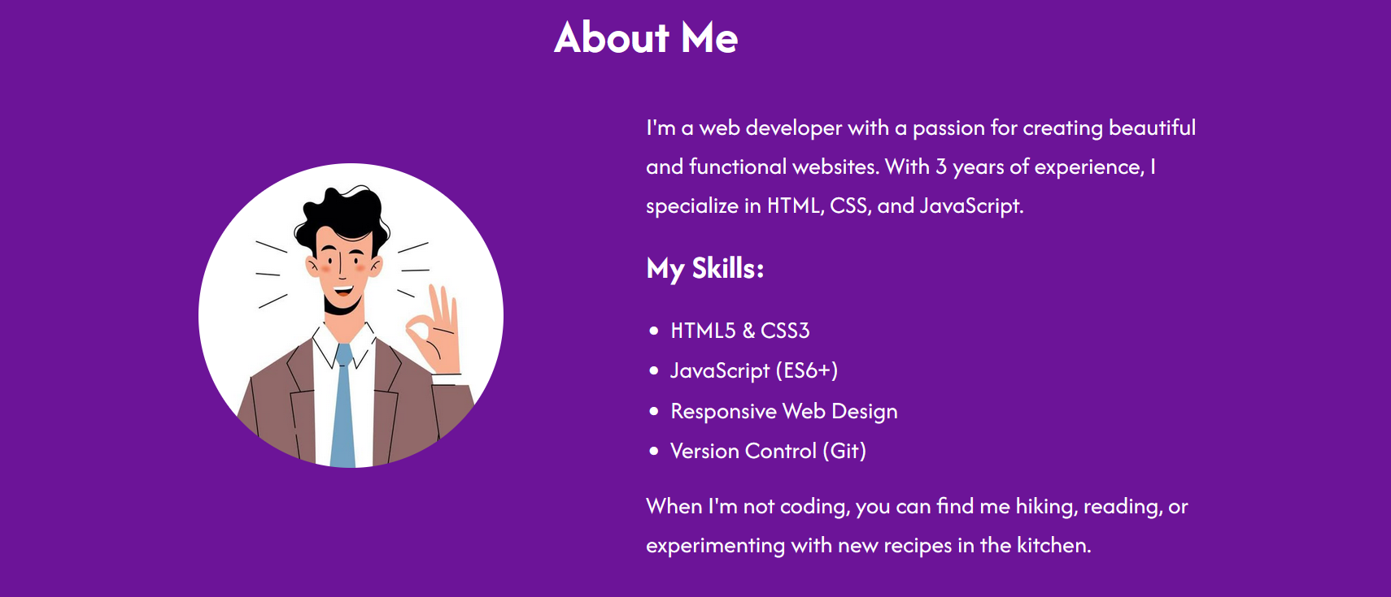

3.My-Projects Page:-

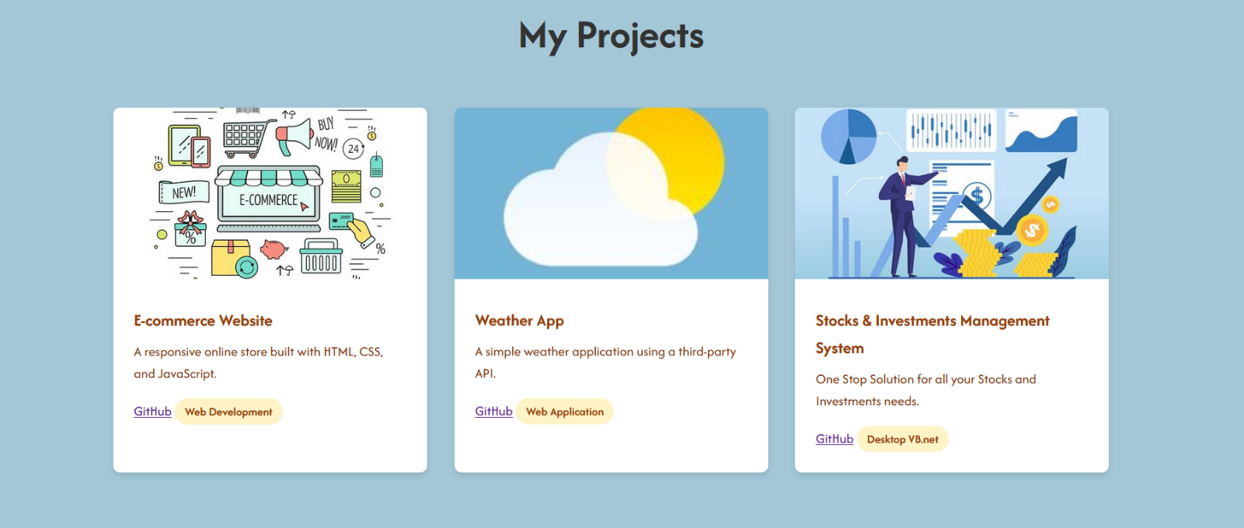

4.Resume Page:-

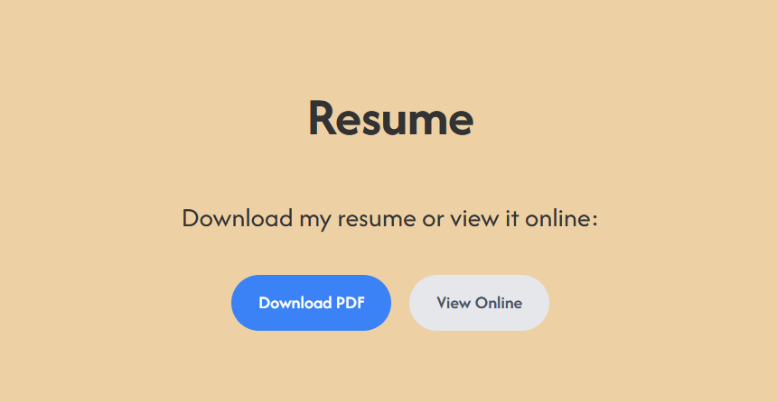

5.Contact-Me Page

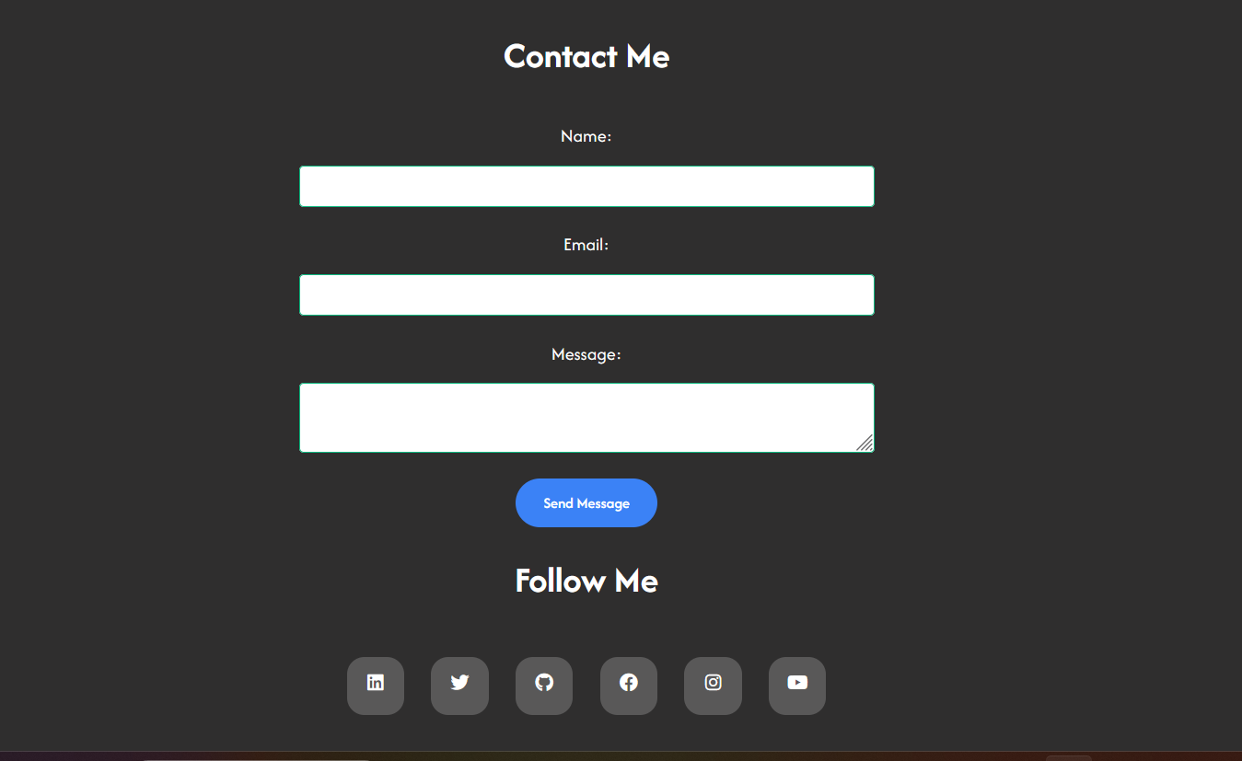

**Project Links :-**

* Github:- <https://github.com/Sevanthatgit/intership-project.git>
* Images:- <https://github.com/Sevanthatgit/intership-project/tree/main/images>

**Instructions:-**

* Please follow the file structure as followed in GitHub.
* Make sure all the images are stored in separate folder named “images”, Within the project folder.